The TCP/IP Protocol Suite

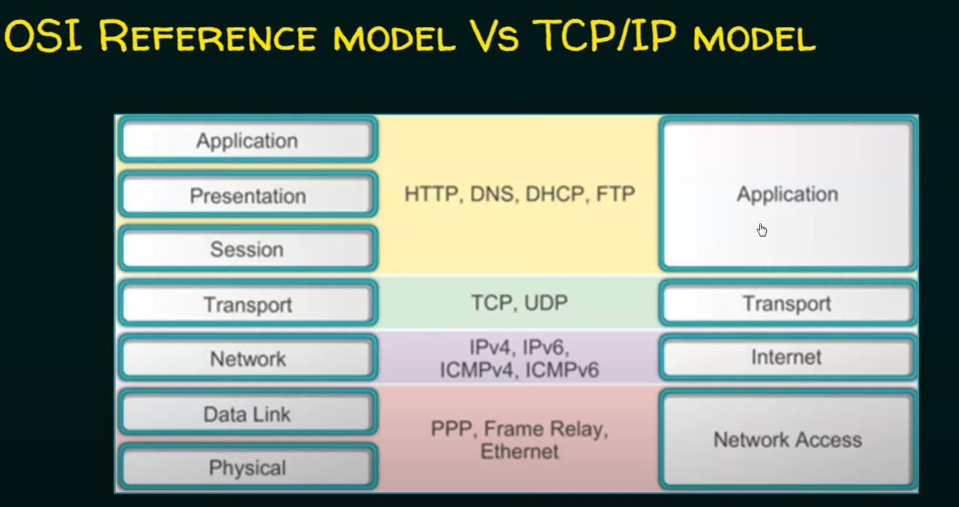

Explanations:

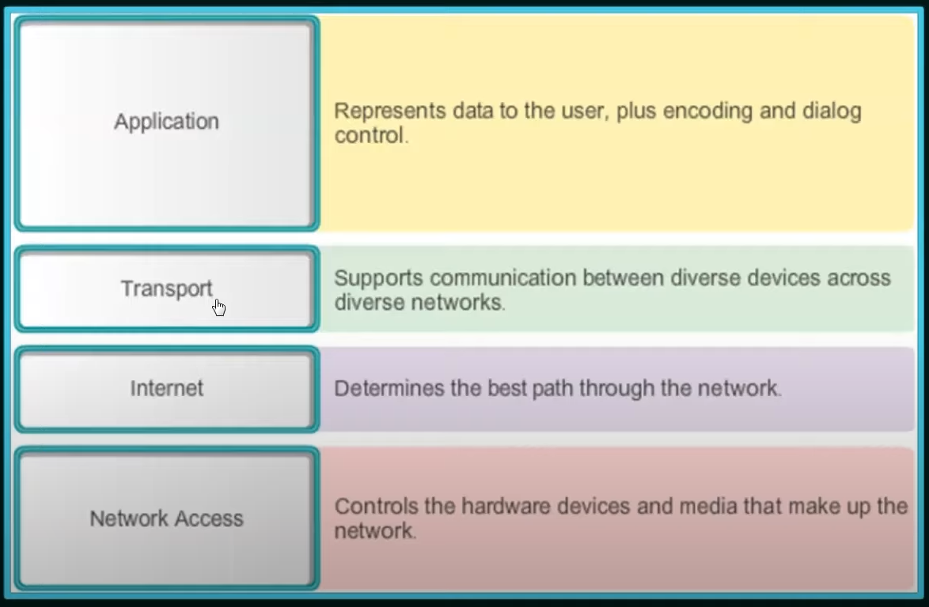

Protocols:

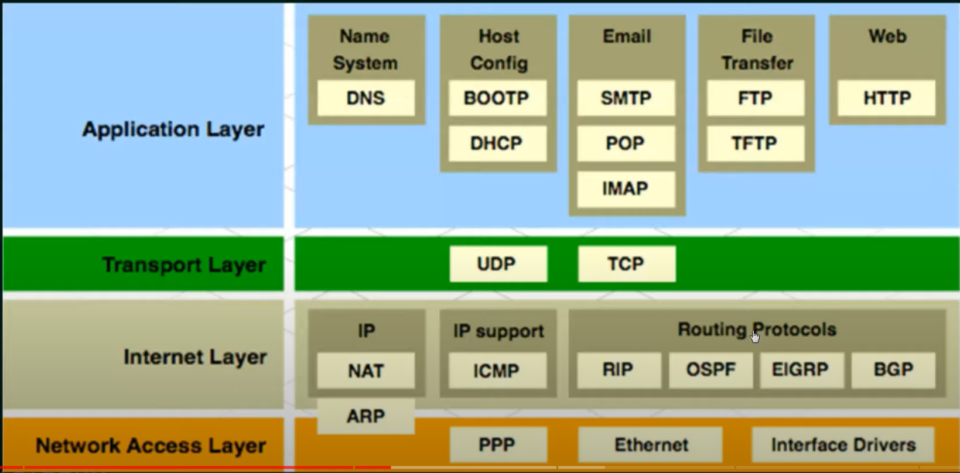

Protocol Data Unit (PDU)

Protocol data units are named according to the protocols of the TCP/IP suite: data, segment, packet, frame, and bits.

Ex:

